**Ahmer Aziz**

**4124**

**Assignment # 1:**

**Hiring Process in a Company:**

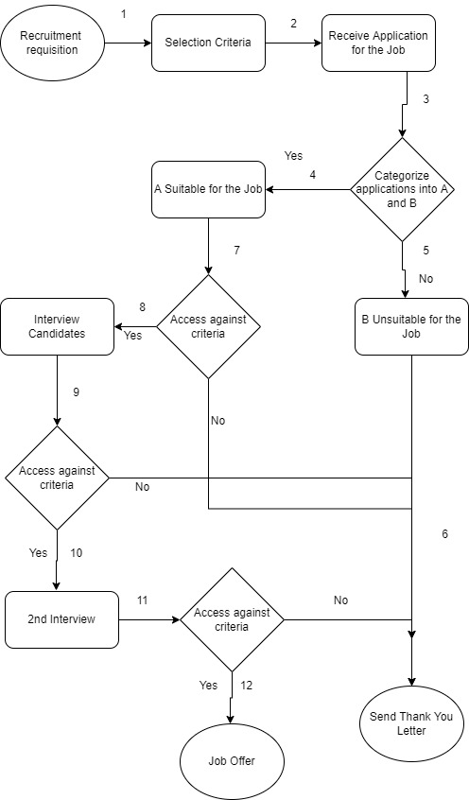

|  |  |  |
| --- | --- | --- |
| **Sr. #** | **Groups** | **Description** |
| 1 | 1,2,3,5,6 | Unsuitable for the Job due to requirement. |
| 2 | 1,2,3,4,7,6 | Suitable for the Job but Rejected due to criteria. |
| 3 | 1,2,3,4,7,8,9,6 | Suitable for the job but rejected due to fail in 1st Interview. |
| 4 | 1,2,3,4,7,8,9,10,11,6 | Suitable for the job but rejected due to fail in 2st Interview. |
| 5 | 1,2,3,4,7,8,9,10,11,12 | Job Offer. |